8 Fines Are Being Lost Progressively Through the Conveyor Ecosystem
Recurring fines accumulation was observed across multiple underground and surface conveyor areas. The repeated relationship between deposits and return-belt/support-roller areas is consistent with carryback being a major recurring mechanism, particularly downstream of discharge locations. The photographs demonstrate the accumulated consequence, but they do not establish that every individual deposit has the same sole origin.
The cross-system recurrence is important because the visible deposit may occur some distance downstream of the cleaner or discharge point where residual material should originally have been controlled. Material remaining on the return belt can detach progressively as the belt flexes and passes over rollers; return rollers/idlers can dislodge and redistribute additional adhered fines. Wet or sticky fines can be more persistent, although the cleaner-control philosophy applies to both wet and dry residual fines and the report does not assume one common water source for all locations.
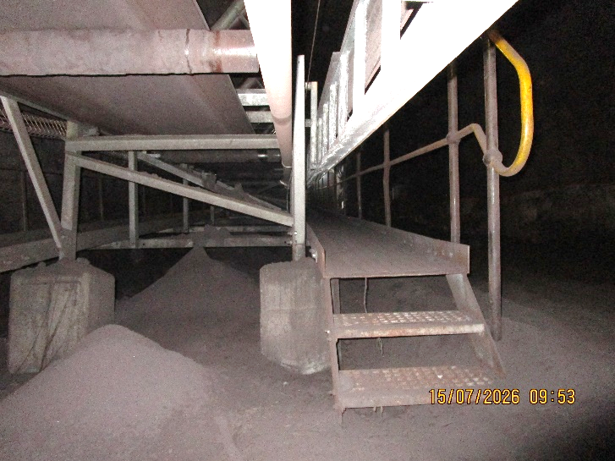UGUC05_04_03_02_01-REF-010 — wider longitudinal accumulation supporting recurrence along the underground route. | 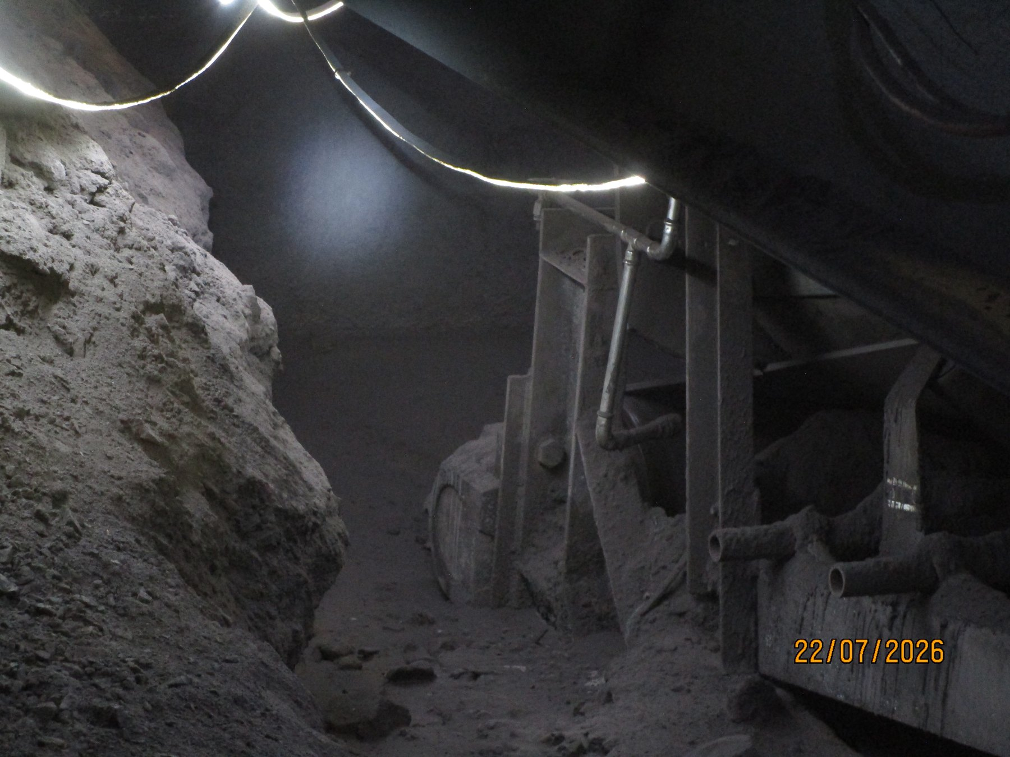  UG5A-REF-006 — widespread return-side accumulation at U5A.
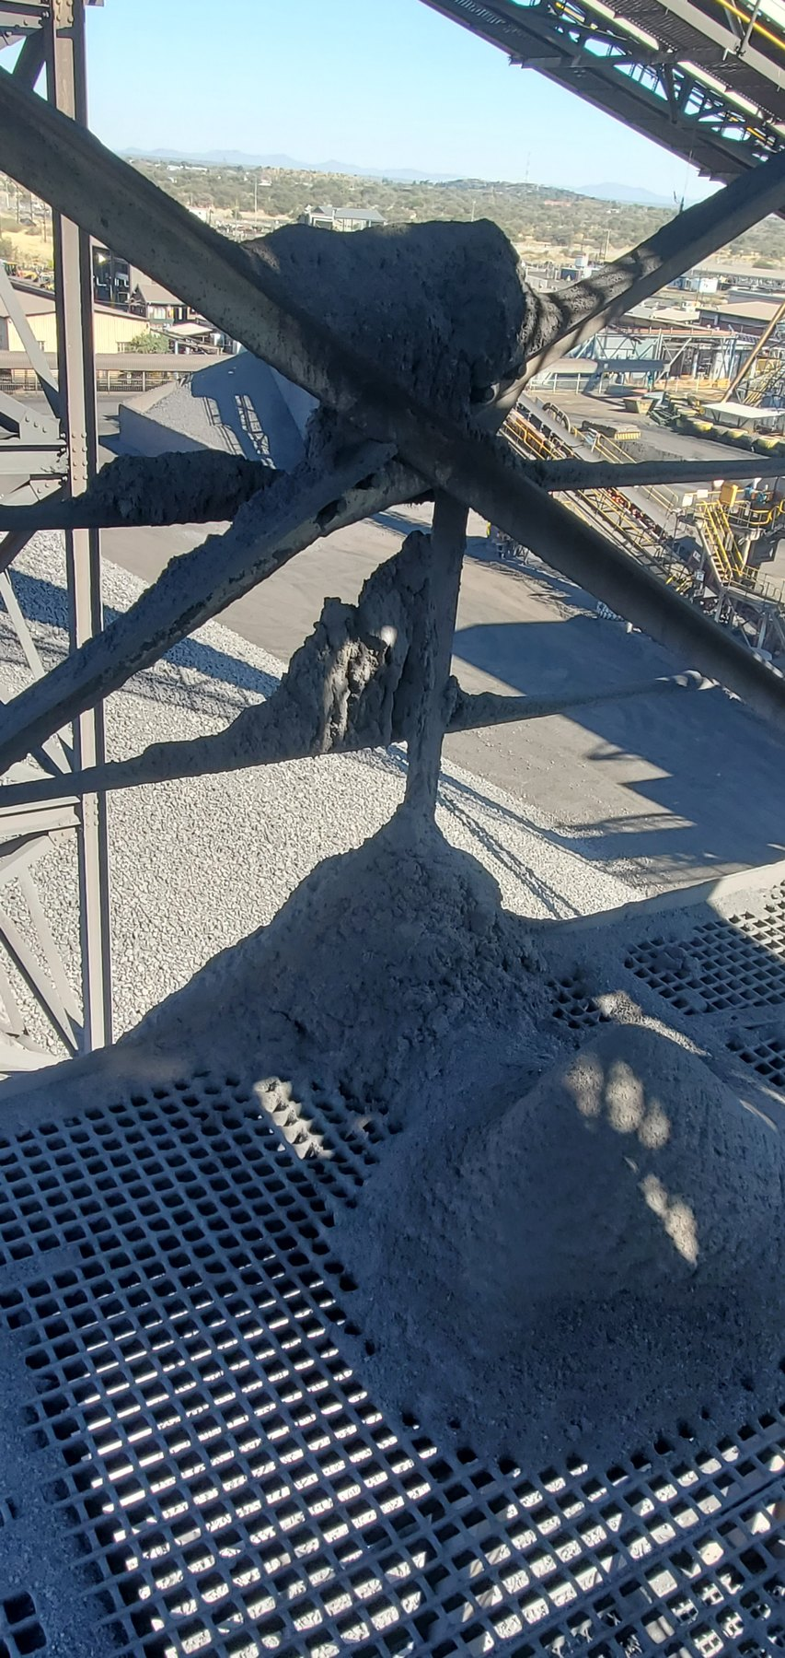  CV15-REF-004 — large fines deposits on grating/cross-bracing around the CV15 discharge region. | 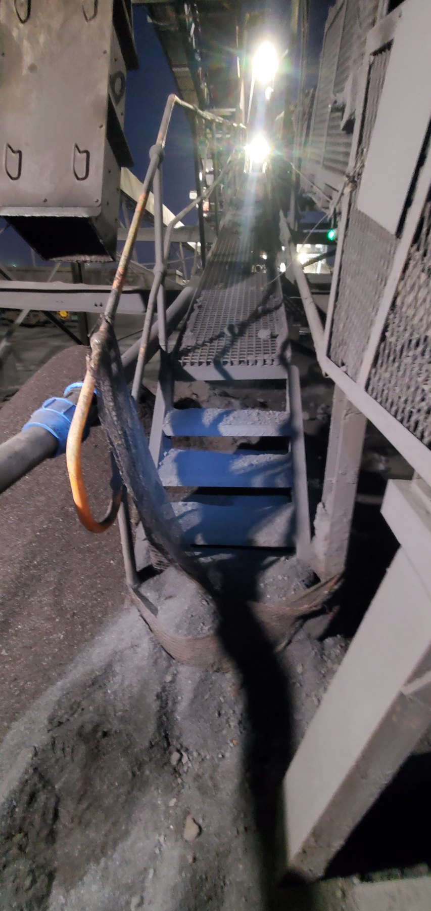  LoadoutStationSample1-REF-002 — substantial fines accumulation around the Sample Conveyor 1 tail/access area.
SYSTEM PATTERN | Carryback is a recurring system mechanism, not an isolated conveyor event. The report therefore focuses on cleaner function and containment at relevant discharges while retaining the evidence qualification applicable to each individual deposit.

